NAME: ALVEENA NAZ
REG NO. FA25-BSE-010
OOP LAB ASSIGNMENT 3

Question 1:
//Main class
public class JavaApplication58 {
public static void main(String[] args) {

String bookTitles[] = {"PF","OOP","DSA"};
BookCollection b1 = new BookCollection(bookTitles);

if (b1.hasNext(0)){
System.out.println("Index has book Title.");
}
else{
System.out.println("Index does not have book Title.");
}

System.out.println("Book title: " + b1.getNext(2));
}

}

//Interface IterableCollection
public interface IterableCollection {
public boolean hasNext(int index);

public String getNext(int index);
}
//Book collection class
public class BookCollection implements IterableCollection{
String bookTitles[];

BookCollection(){}
BookCollection(String titles[]){
this.bookTitles = titles;
}
@Override
public boolean hasNext(int index){
if(!bookTitles[index].isEmpty()){
return true;
}
return false;
}

@Override
public String getNext(int index){
return bookTitles[index];
}

}

OUTPUT:
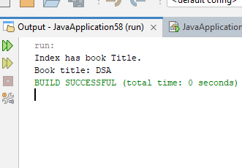

Question 2:
import java.util.Scanner;
import java.util.ArrayList;
import java.util.Collections;
public class JavaApplication59 {
public static void main(String[] args) {
Scanner input = new Scanner(System.in);
ArrayList<Double> scores = new ArrayList<>();
System.out.println("Enter Degree of Difficulty. (1.2-3.8)");
double degree = input.nextDouble();

System.out.println("Enter score for seven Judges(0-10)");

for(int i=0;i<7;i++){
System.out.println("Enter Score of Judge "+ (i+1));
double score = input.nextDouble();
scores.add(score);
}

double highestScore =Collections.max(scores);
double lowestScore =Collections.min(scores);

scores.remove(highestScore);
scores.remove(lowestScore);

double sum =0;
for(int i=0;i<scores.size();i++){
sum+=scores.get(i);
}

double diverScore = sum * degree * 0.6;
System.out.println("The Diver Score is " + diverScore);

// add the remaining score

}

}

OUTPUT:
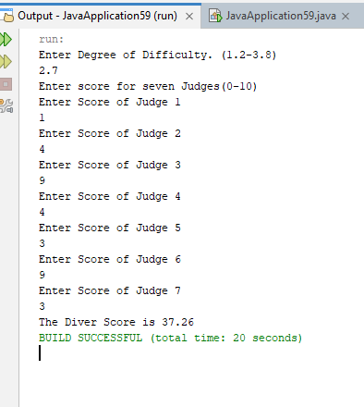

Question 3:
//main class
public class JavaApplication59 {
public static void main(String[] args) {
RandomBox<String> box = new RandomBox<>();
box.add("Ali");
box.add("Sara");
System.out.println(box.drawItem());
}
}

//Generic class
import java.util.ArrayList;
import java.util.Random;

public class RandomBox<T> {

private ArrayList<T> items;
private Random random;

public RandomBox() {
items = new ArrayList<>();
random = new Random();
}

public void add(T item) {
items.add(item);
}

public boolean isEmpty() {
return items.isEmpty();
}

public T drawItem() {

if (isEmpty()) {
return null;
}

int index = random.nextInt(items.size());

return items.remove(index);
}
}
OUTPUT:
